

STUDENT CASE STUDY EXECUTION REPORT

Department | FED
Subject | DSA – 2
Academic Year | I-III Semester (2025 – 26)
Faculty Name | Ms. Mamatha
Student Name | Uppalapati Venkata Naga Varshitha
Roll Number | 2520030206
Branch | CSE
Course Outcome | CO 4 – Shortest Path Algorithms for Logistics Optimization

Case Study Title: Delivery Route Optimization using Dijkstra’s Algorithm in SmartLogix

Work Done Summary:
SmartLogix is a logistics and supply chain platform that manages deliveries between multiple warehouses, distribution hubs, and customer locations. In a real-world logistics system, finding the shortest and most cost-effective delivery route is very important to reduce
transportation time, fuel usage, and operational cost.
In this case study, Dijkstra’s Algorithm is used to identify the shortest path between
warehouses in the SmartLogix transportation network. Each warehouse or delivery point is represented as a node, and the distance between them is represented as weighted edges in a graph. The algorithm calculates the minimum distance from a selected source warehouse to all other connected locations.
By applying Dijkstra’s Algorithm, SmartLogix can optimize route planning, improve delivery scheduling, and ensure faster shipment movement across the network. This case study
demonstrates how shortest path algorithms are useful in real-time logistics optimization and intelligent transport management systems.

Implementation Details:
- Represent the SmartLogix delivery network using a weighted graph
- Treat warehouses, hubs, and delivery points as vertices
- Represent road distances or delivery costs as weighted edges
- Apply Dijkstra’s Algorithm to find the shortest route from the source warehouse
- Calculate minimum delivery distance to all connected locations

- Display the optimized shortest paths and total cost of travel
- Improve route planning and logistics efficiency using shortest path analysis

Result:
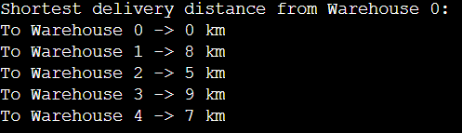
The implementation of Dijkstra’s Algorithm successfully optimized delivery route planning in the SmartLogix logistics network. The algorithm efficiently calculated the shortest path from the selected warehouse to all other connected locations. It reduced route complexity,
improved delivery planning accuracy, and demonstrated how shortest path algorithms can support smart transportation and logistics optimization.
Time Complexity:
- Graph Representation: O(V + E)
- Dijkstra’s Algorithm using Priority Queue: O((V + E) log V)
- Distance Update Operation: O(log V)
- Display Shortest Paths: O(V)

Github Link: https://github.com/srinivasvarshi7-beep/DSA-2-Casestudy.git

Student Signature: | Faculty Signature:

